Final Project Initial Proposal:

Neural Network Classification of Brain Cancers

Brain cancers and their associated tumors are an incredibly difficult and challenging field within medicine. The difficulty of brain tumors falls into where the tumors themselves are in the body- the brain. Having a mass growing in what is arguably the most important part of the body poses a slew of difficulties and dangers for the unfortunate patients dealing with such troubles. Due to the brain’s unique and distinct structure, the space for any kind of mass is nonexistent and hence incredibly dangerous. In addition to the inherent risks associated with performing any kind of procedure with respect to the brain, the brain’s complexity is also a challenge that needs to be addressed. This project’s goal will be to take magnetic resonance images (MRIs) of brain tumors and create a classification neural network.

The data used for this project found on Kaggle [here](https://www.kaggle.com/sartajbhuvaji/brain-tumor-classification-mri), holds a collection of brain tumor MRIs. The tumor images are separated into 3 categories along with MRIs of brains without any tumor. The 3 categories of tumors are glioma, meningioma, and pituitary tumors. Each type of brain tumor belongs to a different region of the brain and has a unique structure. In addition to the images all being characteristically different between each other, each set of MRIs has images from different orientations. While this type of variance within the MRIs taken may pose an issue in the near future, having the availability of such images can be used to build more robust models. This will also become a point of discussion when data preparation is addressed.

As with all projects there must be a driving reason propelling the project forward. More importantly however, a discussion of “why” must be had. Health science technologies is an area where healthcare and technology meet providing effective and reliable tools for professionals. The use of machine learning (ML) and deep learning (DL) is a relatively novel aspect of health science technologies and while cutting edge in the industry of healthcare, falls behind in the realm of technology. Classification is an especially difficult and precarious aspect of ML for healthcare. Classification models must be incredibly robust and function with incredibly high-performance metrics. Even with such measures there is still lots of discussion surrounding how much influence classification models should have when discussing treatments and assessments of patients. The reason being that they provide some level of influence on the outcomes of treatment of patients which often impacts them their entire lives. When discussing strictly abnormality detection however, there is more leniency for the presence of models in the healthcare world. Abnormality detection can help ensure medical professionals don’t overlook an aspect of patient treatment but don’t directly impact what kind of treatment decision to make for a patient.

As with all projects, there are going to be issues and setbacks- no good project is without them. The first and most prevalent issue our team foresees is confusion in our model with respect to what is being classified versus extraneous objects in the MRIs.

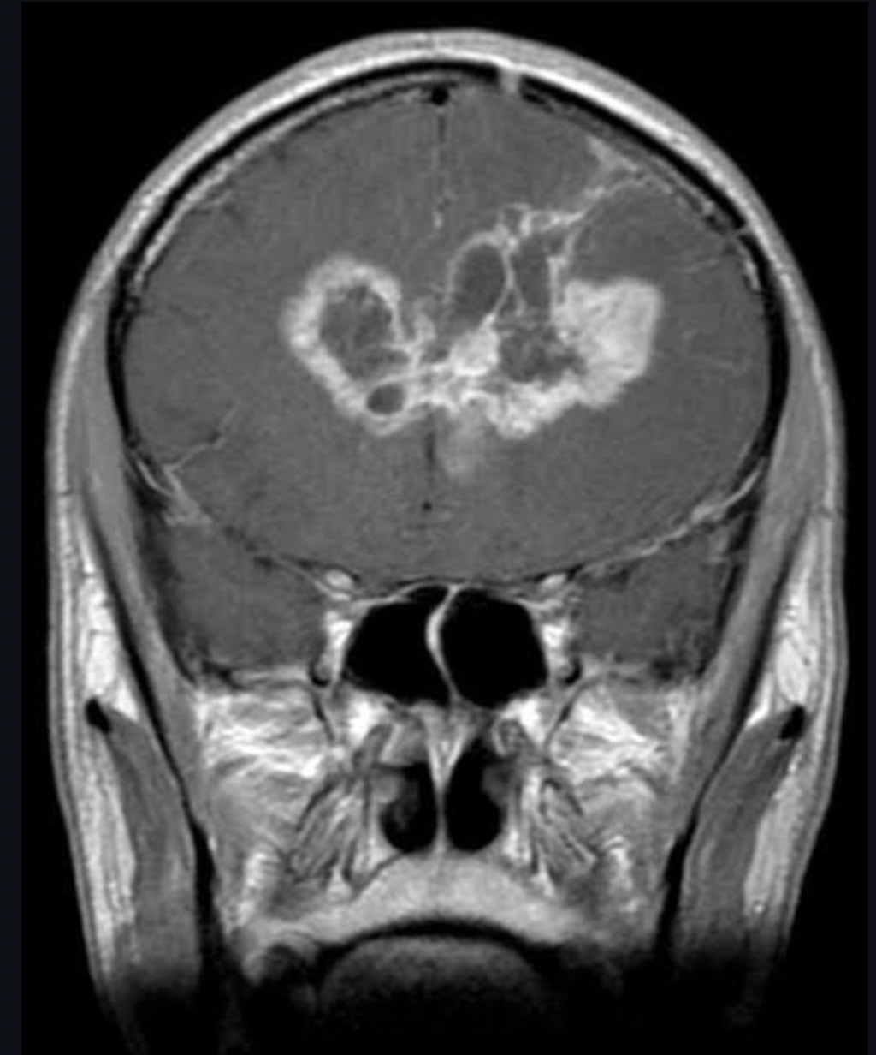



Figure 1

Take Figure 1 above for reference, the mass in red is a cancerous glioma tumor. This is what we would want our models to be able to classify. However, it’s possible that our model instead classifies the areas in blue as being the key classifying attribute. This would be incredibly problematic as the regions in blue are neither cancerous or tumors. One possible solution to this image would involve labeling the actual tumors with their corresponding classifications and then training our models. This would resolve the issue of the model not knowing what to properly classify. One downside to such a solution is the time needed spent properly labeling the images used.

For this project, we’re looking to expand the envelope of cutting-edge health science technology with classification ML models for different brain tumors. We feel that pushing such boundaries even in only a strictly experimental aspect helps to move towards a more technologically unified world.